**COLLEGE FEES MANAGEMENT SYSTEM**



**Computer Science and Engineering Department**

**Indian Institute of Information Technology Guwahati**

**Guided By :-**

**Dr. Rakesh Matam**

**Mrs. Richa Sharma**

**Ashmit Ayush Akash Kapil**

**1801032 1801012**

**Abstract**

There is always a confusion regarding the fees to be paid by a student for each Semester of his/her College. Our “College Fees Management System” aims to remove this confusion by maintaining a proper record of the fee details of the Institute's students by creating a student profile containing contact details and tracking the Tuition fees, Hostel fees, Mess fees and extra charges.

**Introduction**

The application aims to provide transparency regarding the fees management of a College and further avoid the confusion about the fees that has to be paid by a student for each Semester. The application enables the students to view their fees details beforehand and accordingly do the payment at the time of registration. The administration can store all the details about the student on the website. Instantly, he can enter the student Roll no. and update the fee details.

The administration can register students simply by uploading the csv file on the website and can also update the mess bills of each student by uploading the csv file. With the help of our application, administration can provide login credentials to each registered student via email.

After successful login, students can change their password. Students can check their fee details with the help of their login credentials. Students can enquire remotely regarding any fee related issue by filling up an enquiry form. In our application administration can make announcements regarding the fee related matter to inform the students.

**Functional Requirements**

**1) Students would have to login with the help of their Roll No. and Password :**

Our web application has a student login page in which students have to login with their login credentials i.e roll number and password.

**Student Login Page (fig.1)**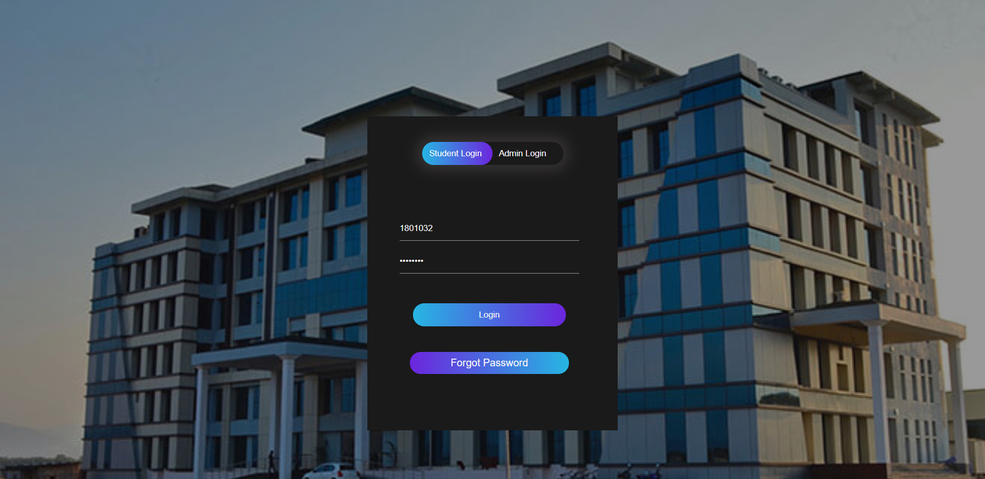

**2) Students can check their semester dues and fees :**

After logging in, students can view their semester fee details.

**Student Semester Fee Detail (fig.2)**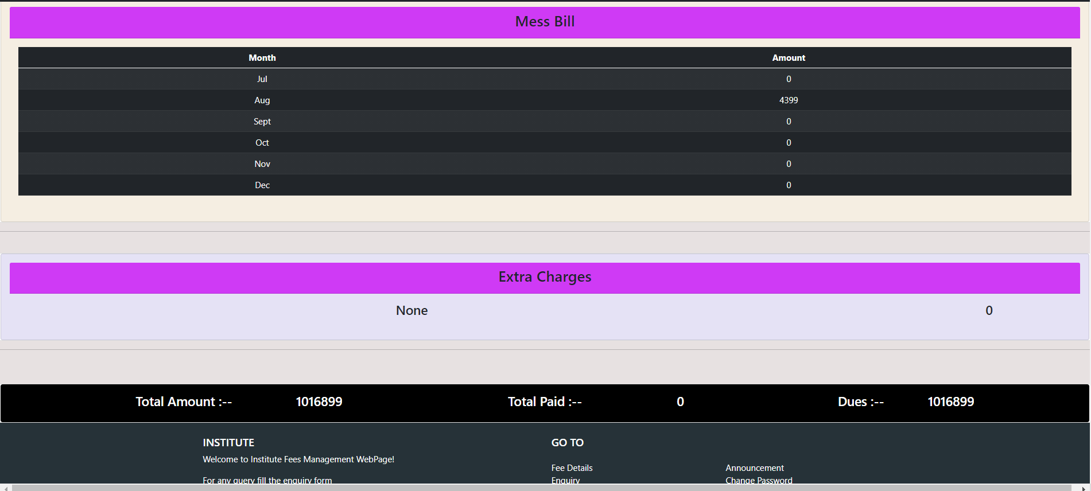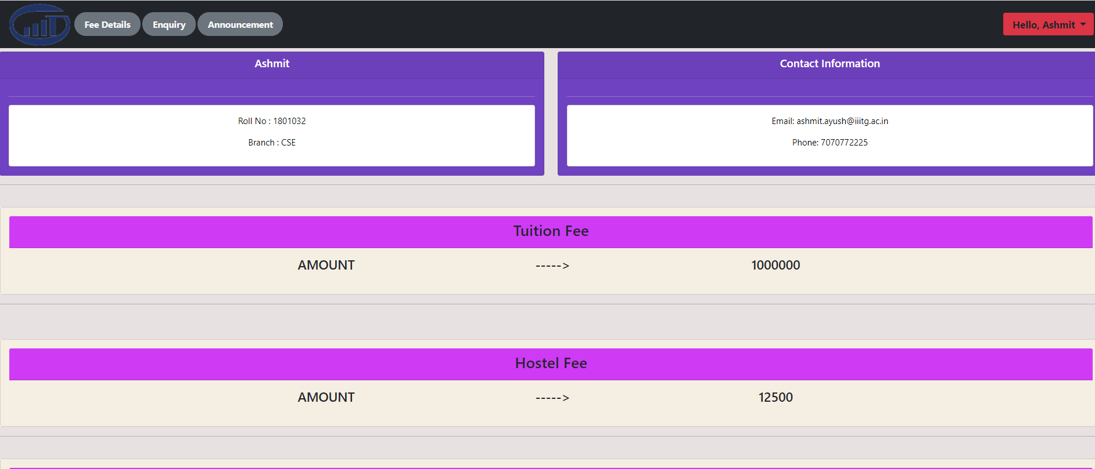

**3) Students can fill up an enquiry form if they have any fee related queries.**

Students can make an enquiry related to their fee details, if any with the help of an enquiry form (fig.3).

Students will receive a confirmation email after form submission (fig.4).

**Enquiry Form Submission (fig.3)**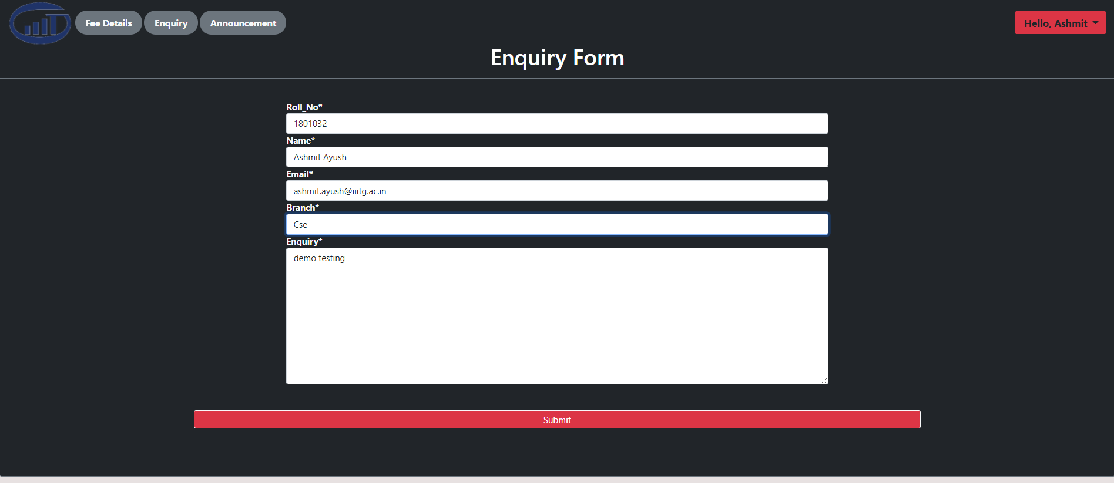

**Confirmation Mail (fig.4)**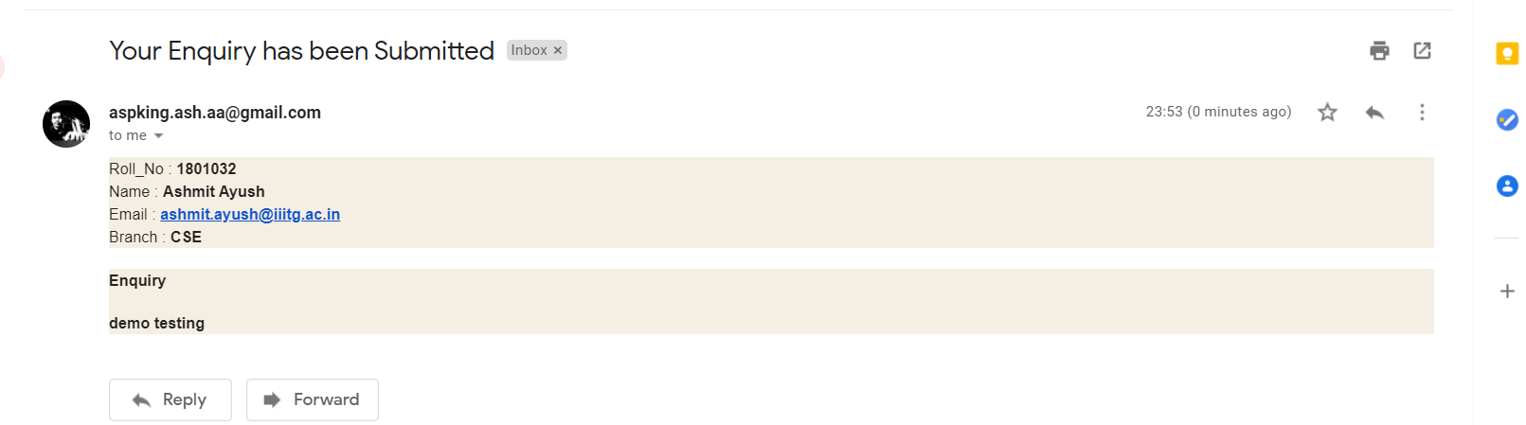

**4) Administrator will register new students.**

Administration can register students by uploading a csv file (fig.5) or even they can register an individual student (fig.6).

**(fig.5)**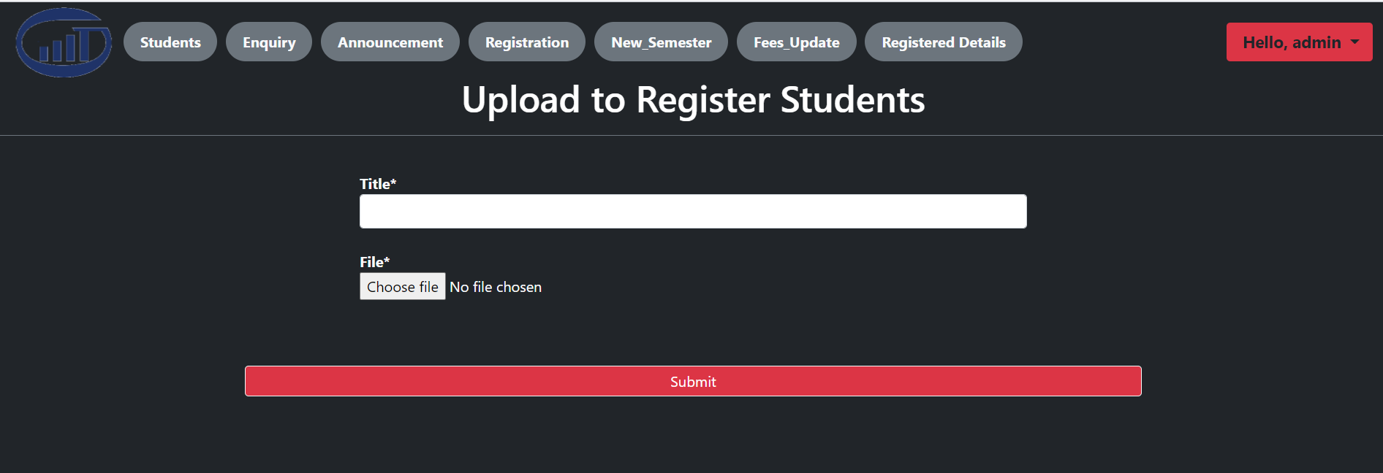

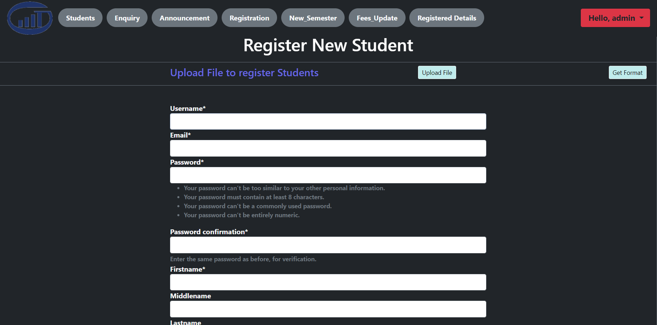

**(fig.6)**

**5) Administrator will have access to view the enquiries made by the students.**

Administrator can view all the enquiries made by the students and can also filter enquiries with date or roll number. They can also change the status of the enquiries.

**Enquiries made by the students (fig.7)**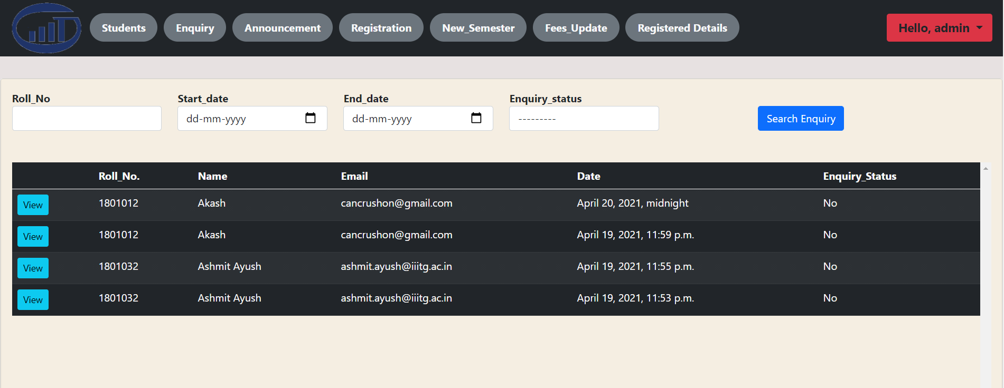

**6) Administrator can make announcements regarding fee related issues.**

**(fig.8)**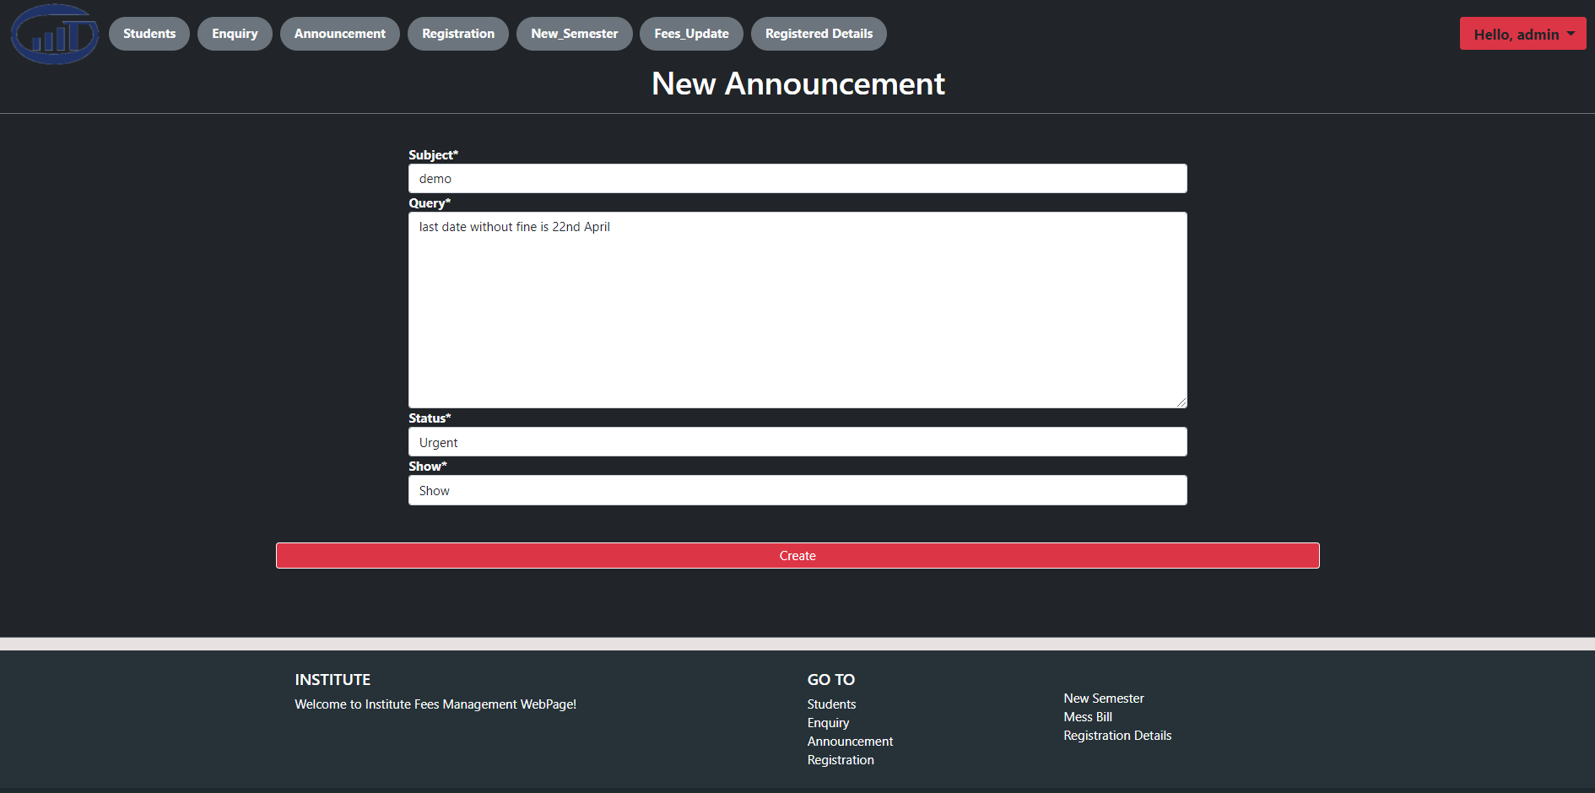

**7) Administrator can view and update the fee payment status of each student.**

Administrator can view fee details of any registered student (fig.9) and can modify fee details if required (fig.10). They can also update the monthly mess bill via uploading the csv file(fig.11).

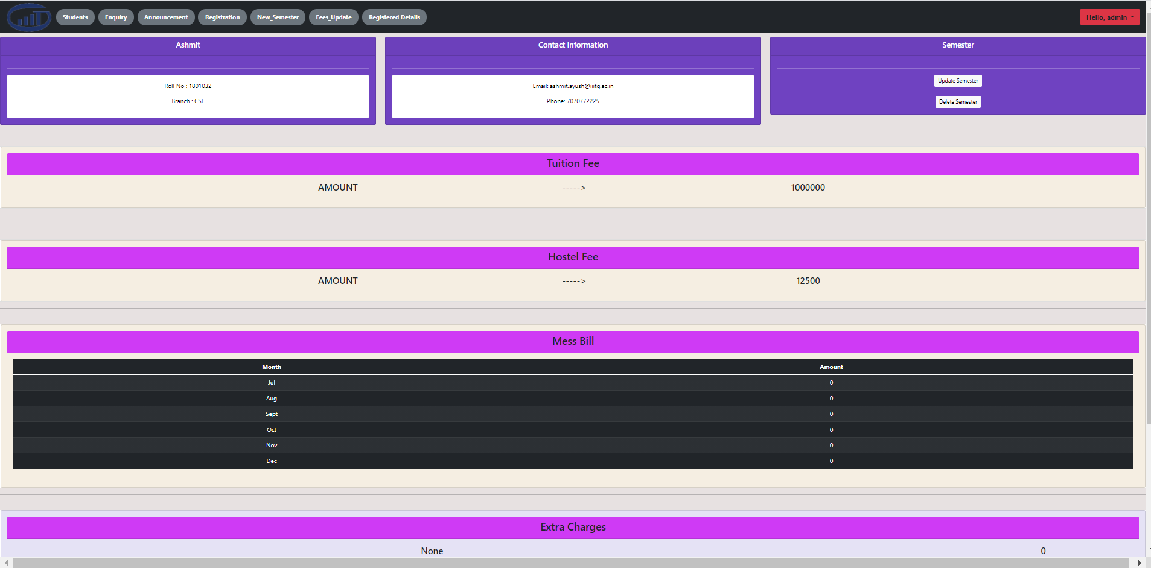

**fig.9**

**fig.10**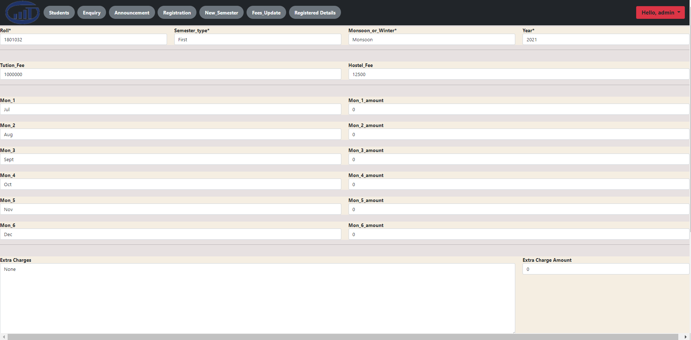

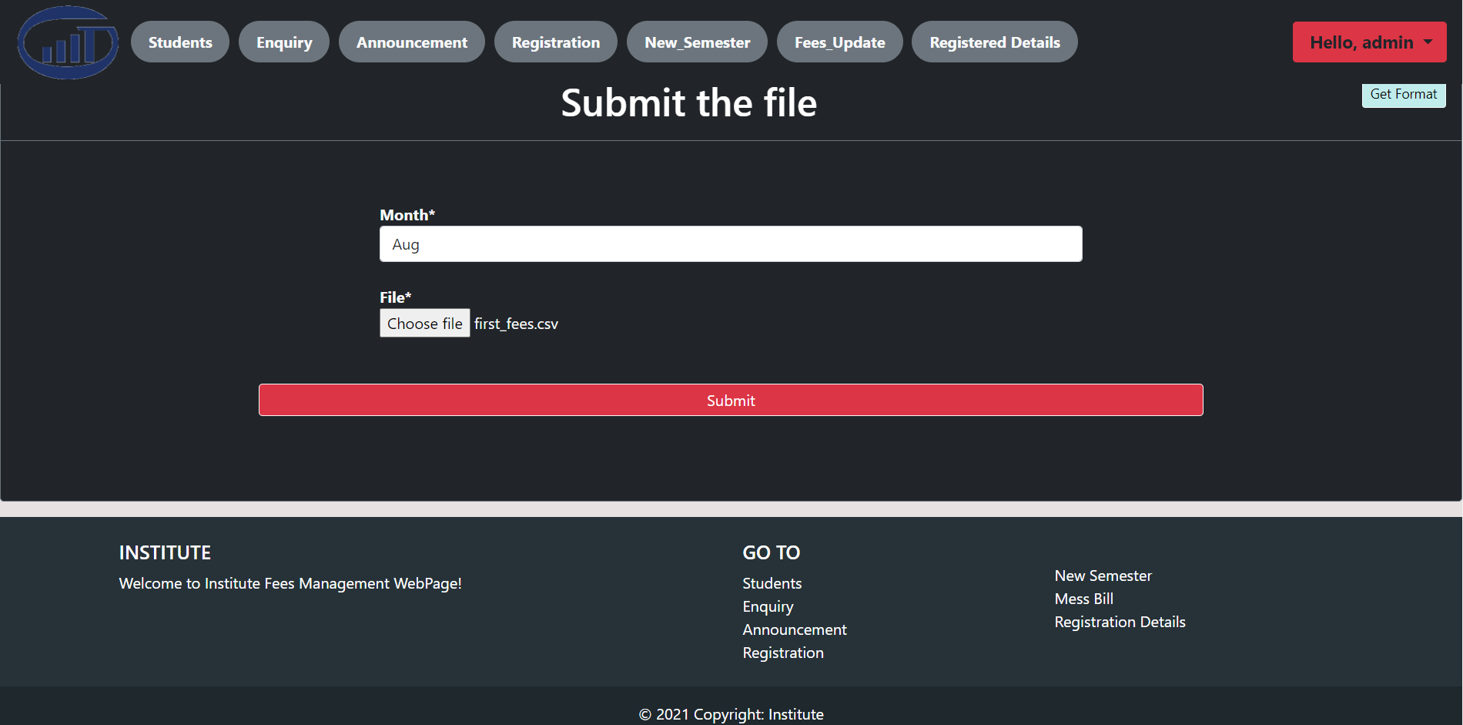

**fig.11**

**Non Functional Requirements**

**1. Our system has an easy to use interface.**

**2. All the data would be secured from unauthorized access.**

**3. Student registration facility is accessible by administration only.**

**Data Flow Diagram**

**Level 0 :**

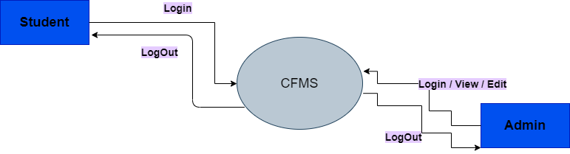

**Level 1 :**

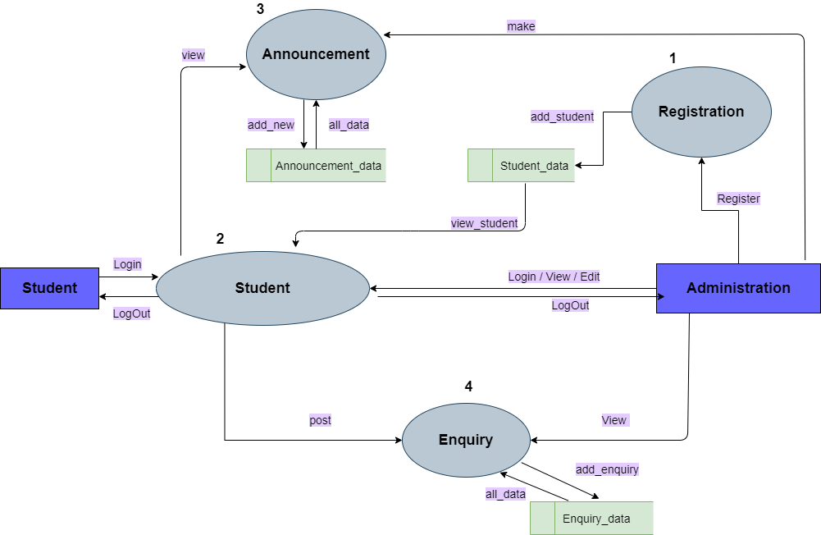

**Level 2 :**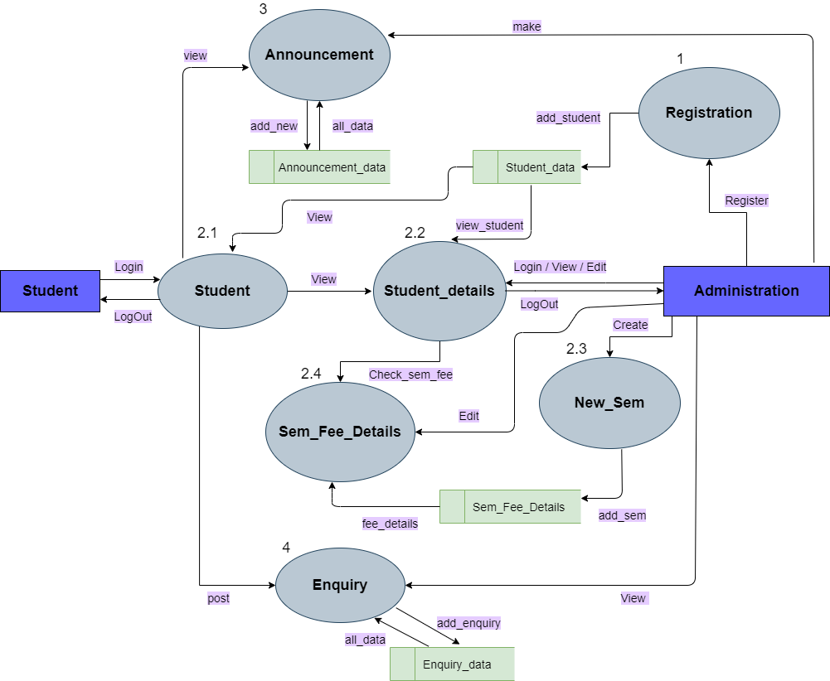

**Use Case Diagram**

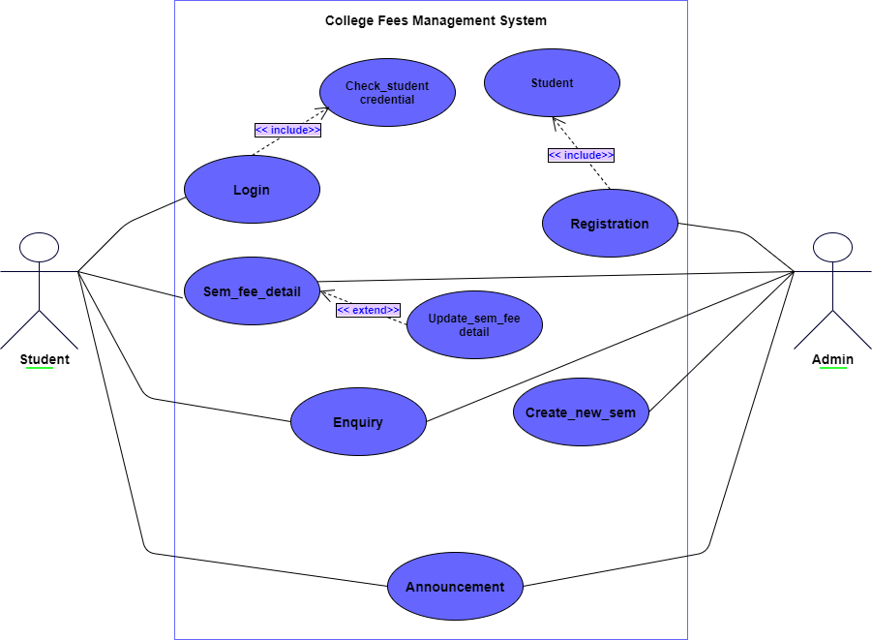

**ER Diagram**

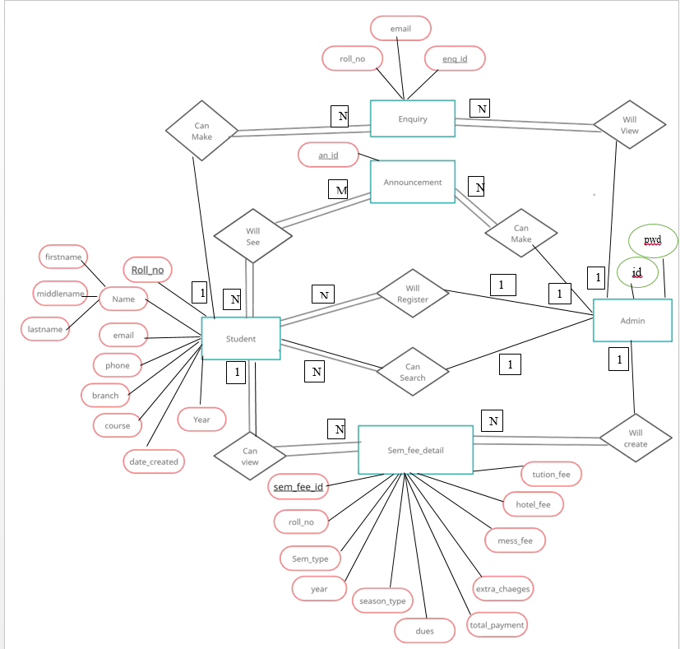

**Sequence Of Application**

**For Students :**

1. **Students have to login with their login credentials on the login page(Student Login).**
2. **After login students can view their all semester fee details.**
3. **Students can fill up an enquiry form by clicking on the ‘Enquiry’ tab, after successfully submitting the form student will receive confirmation mail.**
4. **Students can view all the announcements by clicking on the ‘Announcement’ tab.**
5. **On the right corner of the navbar there will be a dropdown button,on clicking it students will get two options one for changing the password and another one for logout.**
6. **On clicking the logout button students will be redirected to the login page.**

**For Admin :**

1. **Admin will first login on the login page(Admin Login).**
2. **After login on home page admin will have the details of all the registered students.**
3. **On home page admin can filter any student with their roll number by searching.**
4. **On clicking the view button of the student's tab, the admin can see the all the semester fee details.**
5. **On clicking the update button in the semester tab, the admin can update the fee details.**
6. **Admin can see all the enquiries by clicking on Enquiry tab.**
7. **On clicking the new announcement tab within the Announcement page, Admin can make new announcements.**
8. **On clicking the Upload File button within the registration page, admin can upload the csv file of student data to register new students.**

**Implementation**

**We have used the Waterfall Model in developing our web application.**

1. **In the first phase we gathered all possible requirements of the system to be developed .We created the SRS document**
2. **In the next phase we prepared the system design . We created the DFD and Use Case Diagram for the project.**
3. **In the third phase, we started implementing the web application in small units. Each unit was developed and tested for its functionality simultaneously (Unit Testing).**
4. **In the next phase, all the units developed were integrated and tested for any faults or failures.**
5. **Finally we have successfully implemented all the functional and non-functional requirements as mentioned in our SRS document.**

**Technology Stack**

**Database Server: SQL**

**Client: Web browser**

**Development Tools: Microsoft Visual Studio,Github.**

**Framework: Django,Bootstrap 5**

**Programming Language: Python**

**Future Works**

1. **We can add a payment portal in our web application so that direct payment could be possible from the student profile.**
2. **We can also provide graphical statistics of payments for each student to both student and admin.**

**Limitations**

1. **Students cannot directly pay their semester dues from their profile due to unavailability of payment portal.**
2. **No real time notification of announcements for the students.**
3. **No direct interaction between students and administration.**

**Testing Methods Used**

1. **Unit Testing : -** We have performed unit testing to verify the section of code and it’s correctness. Each model has been tested after its completion to check whether it is functioning correctly or not. Forms and Web requests(views) have been individually tested.

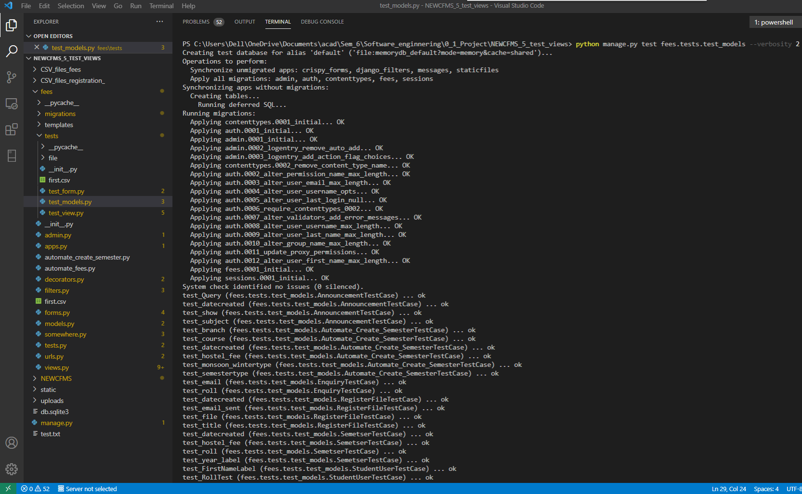

Unit Testing of Models (fig.12)

**Unit Testing of Login Logout (fig.13)**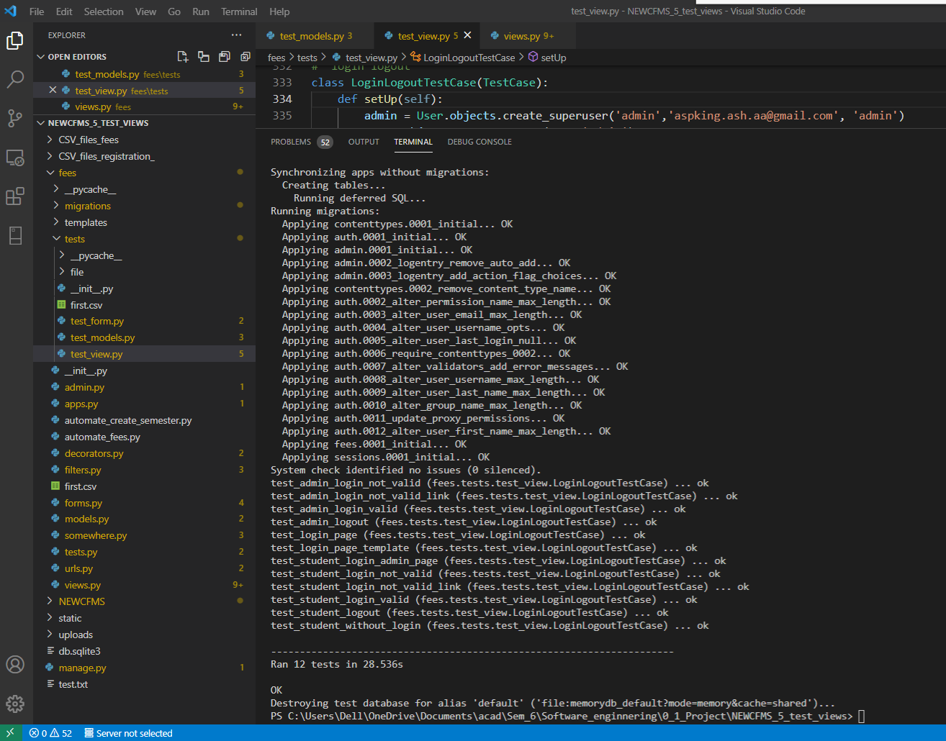

**Unit Testing of Admin Features (fig.14)**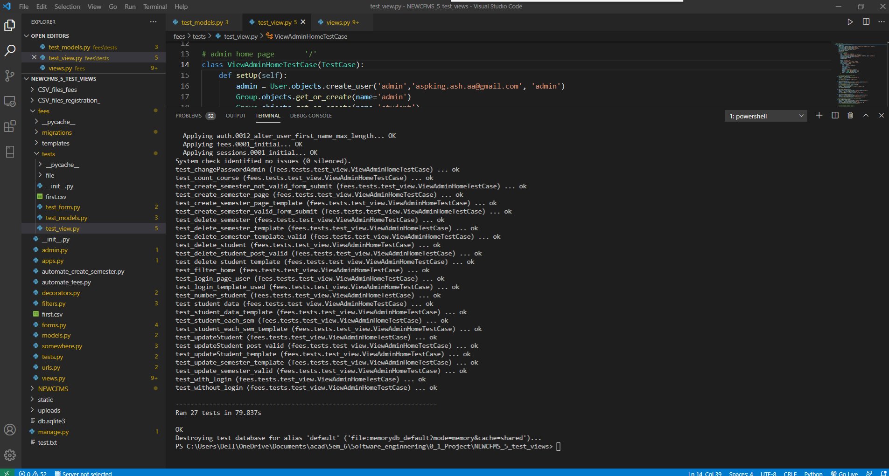

Unit Testing of Registration (fig.15)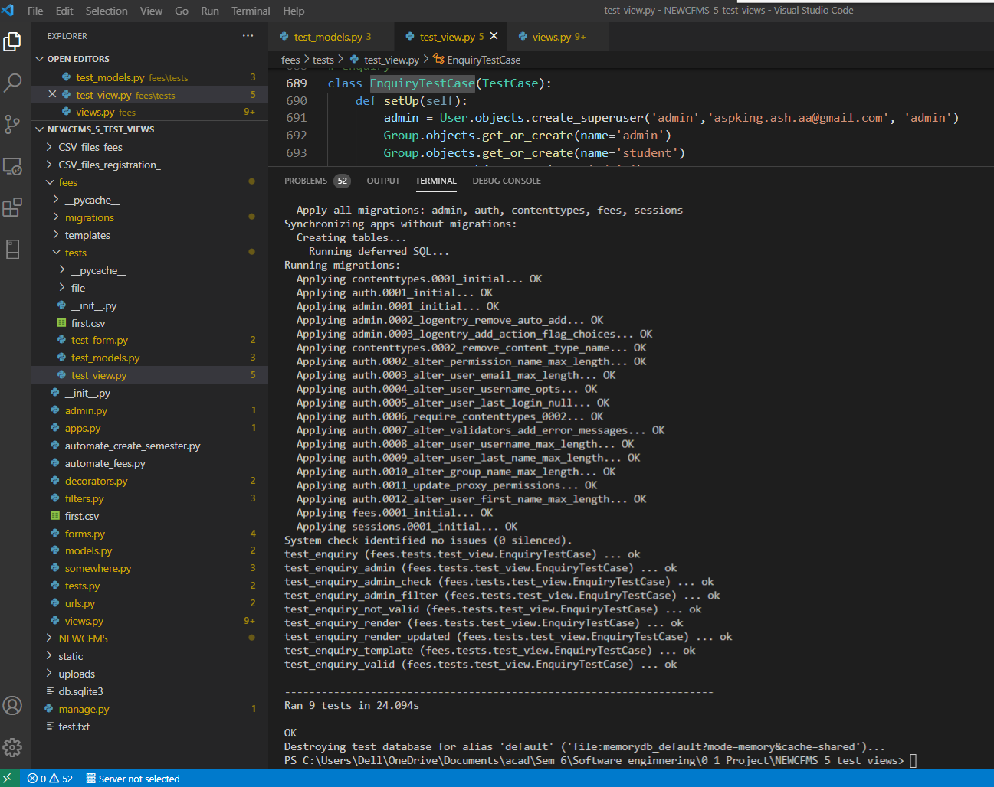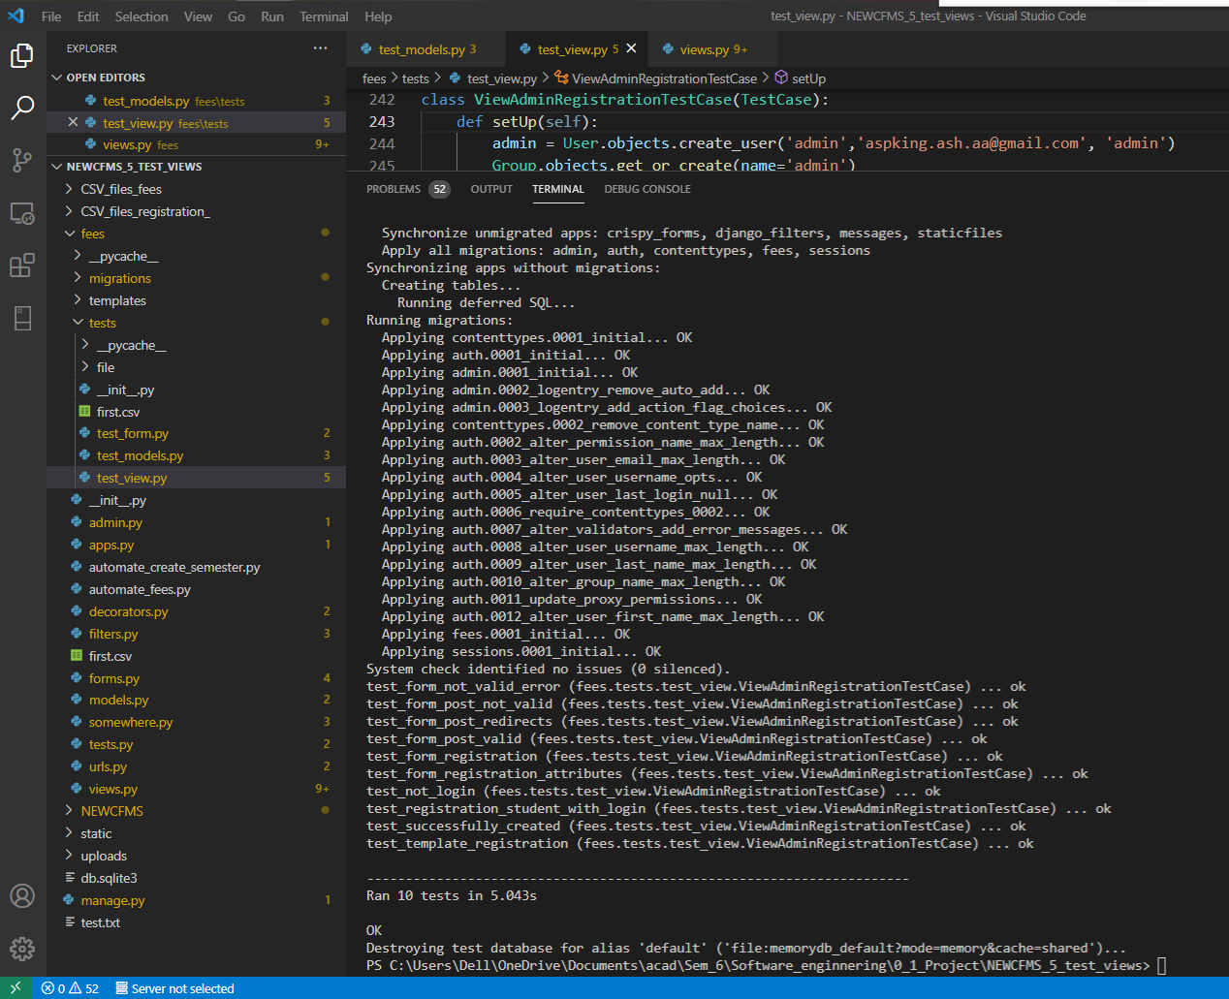

Unit Testing of Enquiry (fig.16)

Unit Testing of Announcement (fig.17)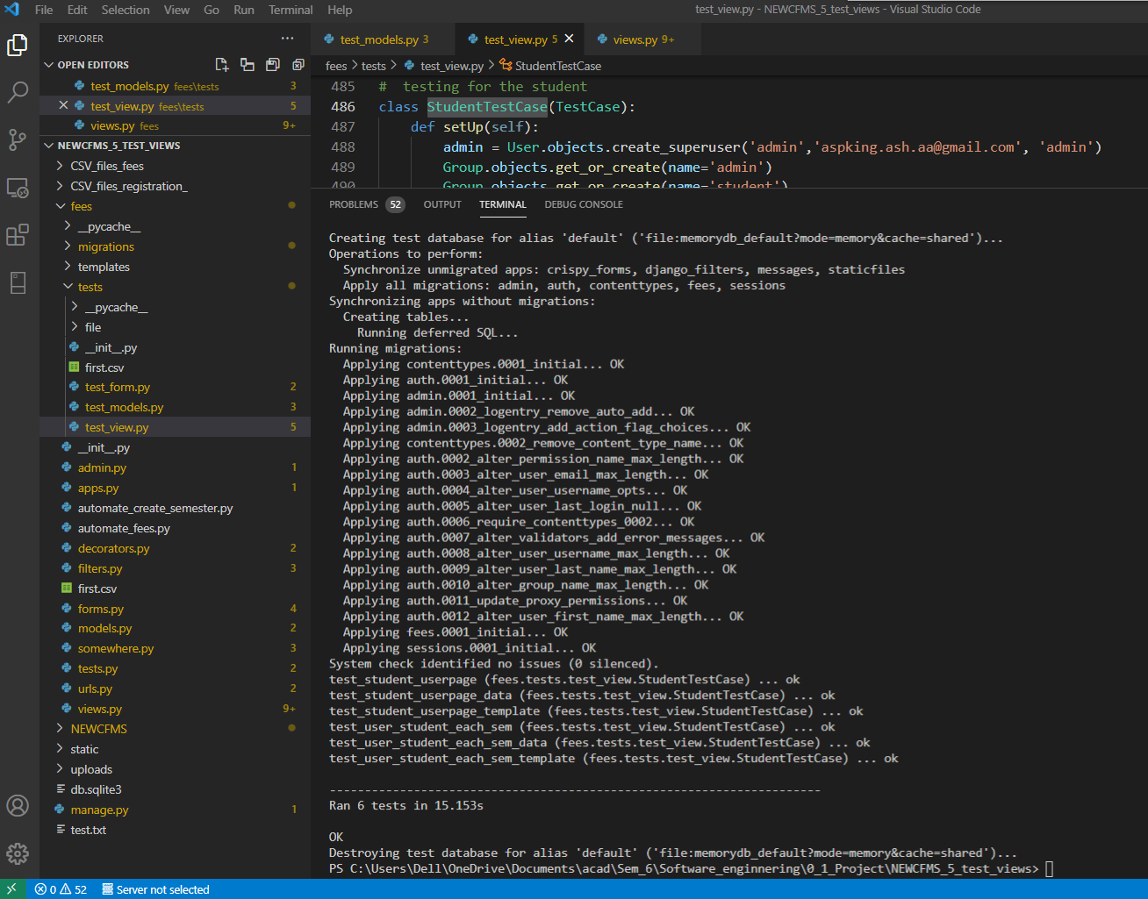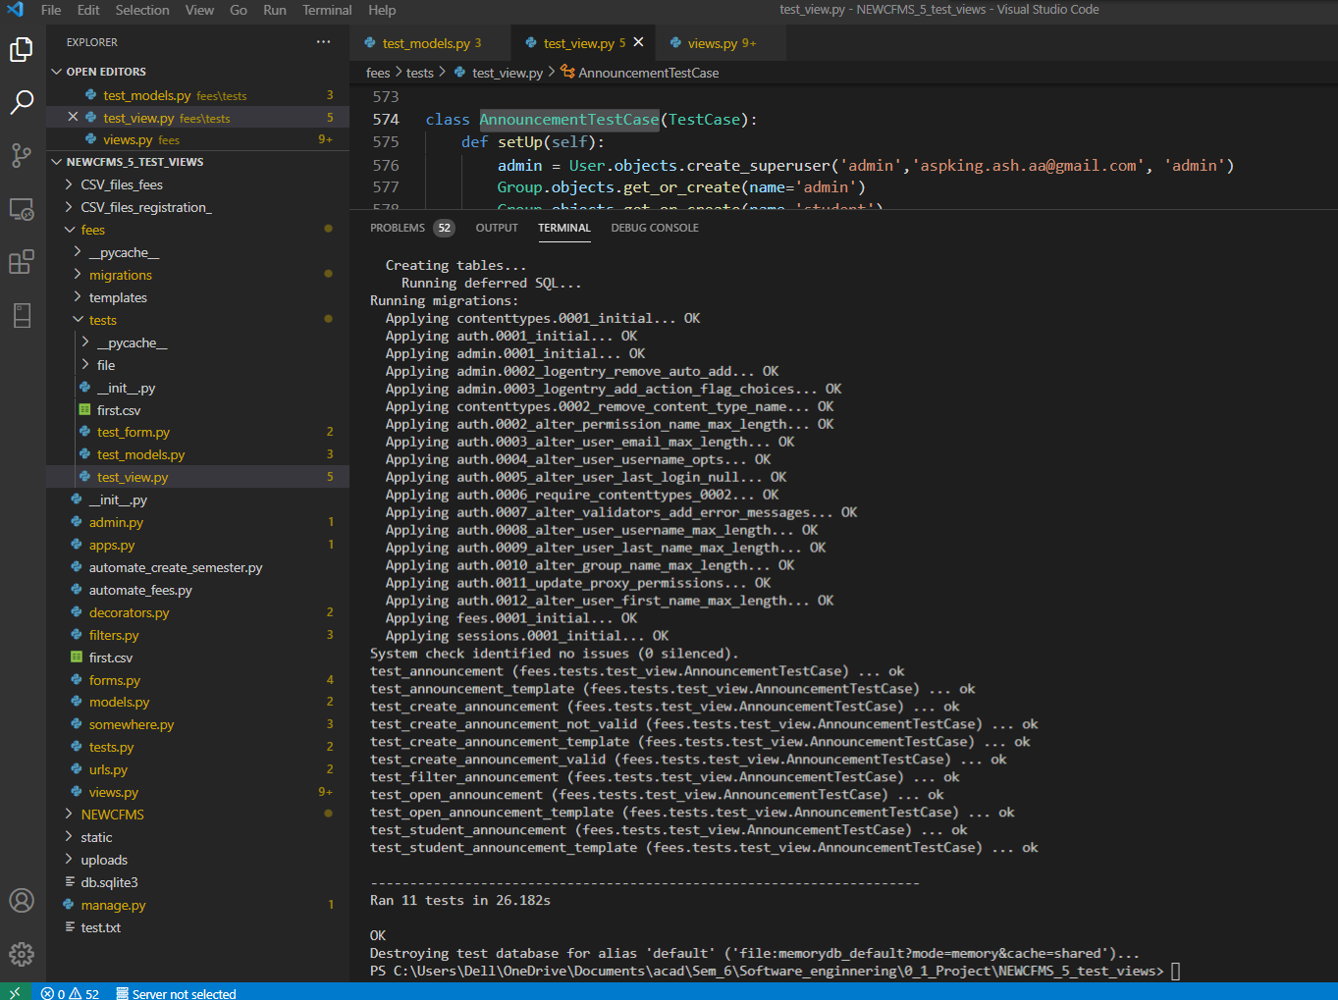

Unit Testing of Student (fig.18)

Unit Testing of Forms (fig.19)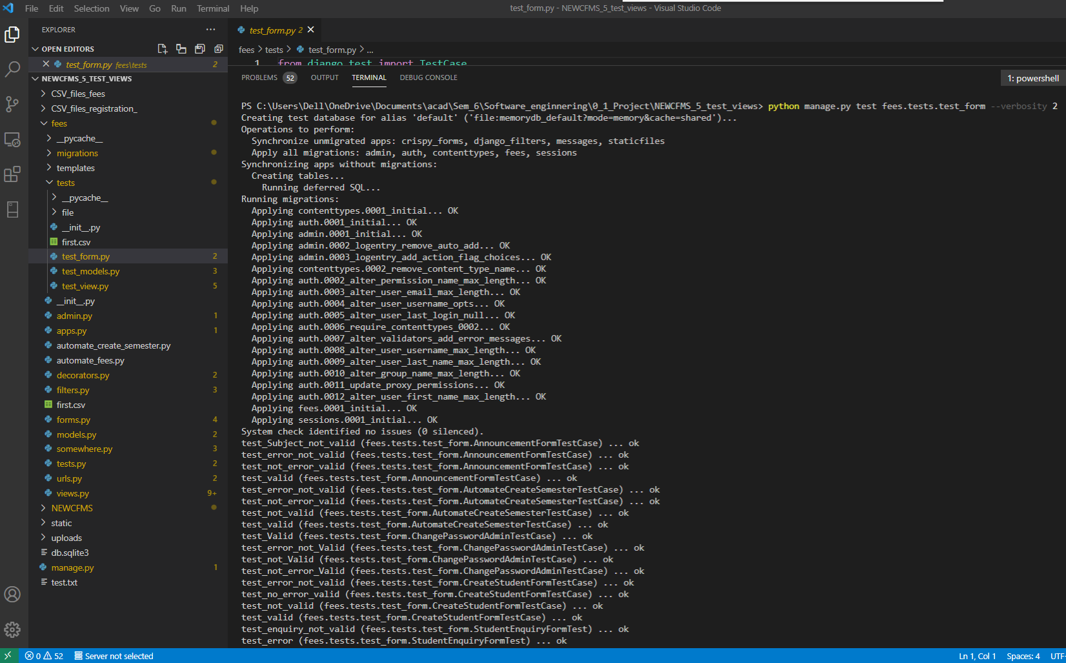

1. **Code review : -** We have reviewed our code in order to remove the vulnerabilities, thereby improving the overall quality of the code.

**Contributions**

**Ashmit Ayush (1801032)**

* Designed the frontend of the Admin interface.
* In the backend
* Developed the Student, Semester, Automate_Create_Semester and RegisterFile database.
* Worked on the authentication section of our web application.
* Automated the registration process, mess bill and semester creation.
* Worked on the web request and on its responses.
* Performed the Unit Testing on the administration interface and on authentication.

**Akash Kapil (1801012)**

* Designed the frontend of the Student interface.
* In the backend
* Developed all the forms of our web application.
* Built the filtration i.e search functionality.
* Developed the Announcement and EnquiryForm database.
* Worked on the web request and responses related to Enquiry and Announcement.
* Performed the Unit Testing on the Student interface.